ASR6546 China label Generate Workorder

1. Master setup
   1. SKU Master – Setup Qty Per Carton.
   2. SKU Work Order – Setup SKU Workorder for China Labelling requirement

EG: 340182

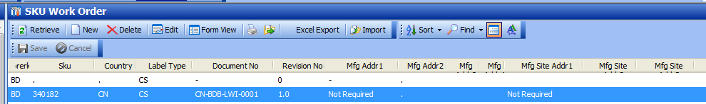

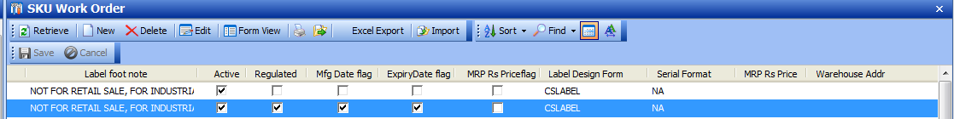

* 1. Importer Customer – Setup Customer ID based on SAP Ship-to code
     1. Added new Print Label required flag, Un-checked if not require to print label from WMS. I.e. CHINA Labeling WO will not require print label from WMS.

Is PrintLabel – set to NO

Print Doc Type = DOCLABELCN

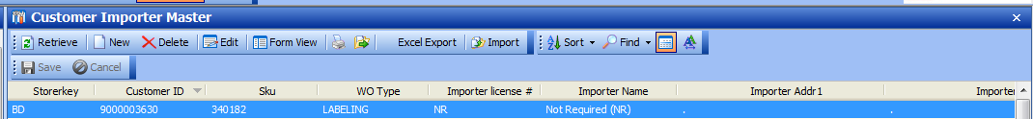

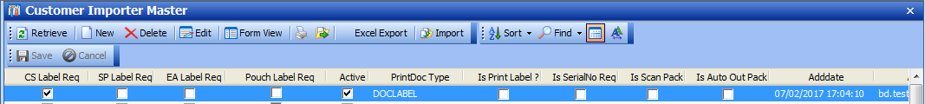

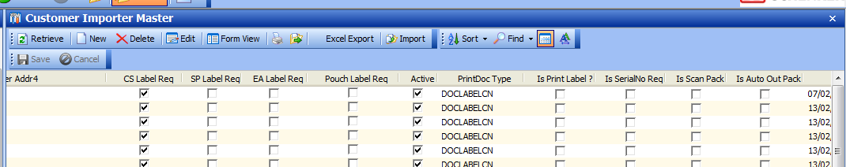

1. SKU Batch Inventory
   1. Add Batch Manufacturing and expiry date

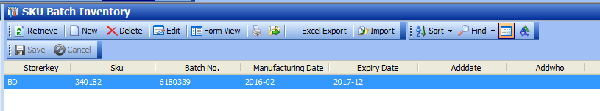

1. Outbound -> Picking management

Work order generation will be same as India Labeling.

Detail indicate – SKU require Labels

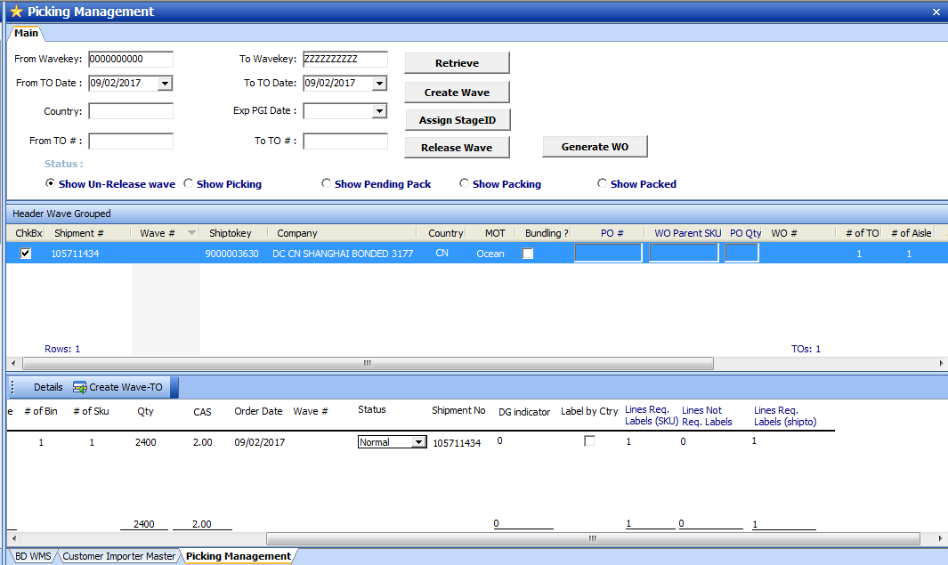

Order Processing Steps:

1. Create Wave
2. Work order generation
3. Assign Stage ID
4. Release Wave

WO Generated:

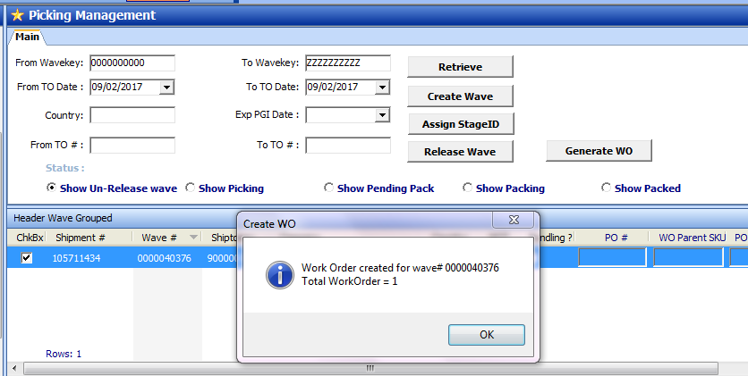

Work order Summary

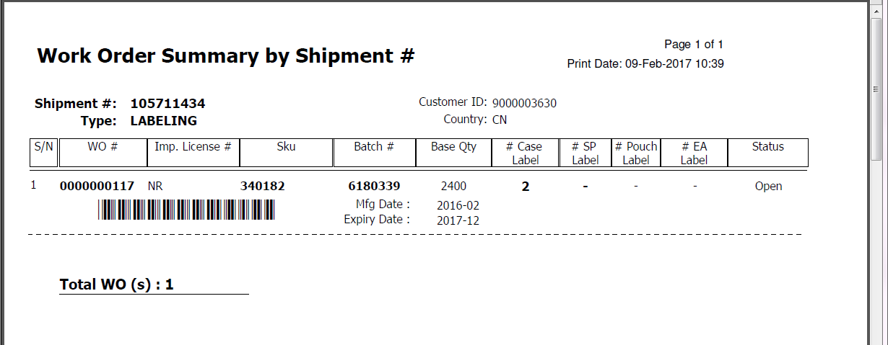

1. Work order process

WO# 117

* 1. Print WO Form

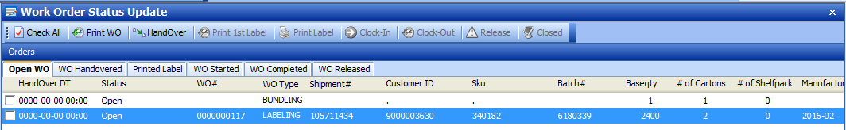

* 1. Handover WO

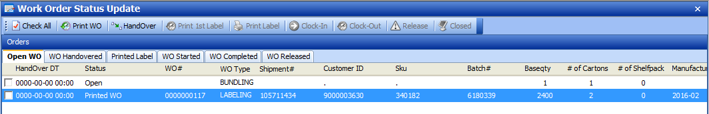

Status directed to “Printed Label”.

LP can proceed to “Clock-In” to start Labeling process.

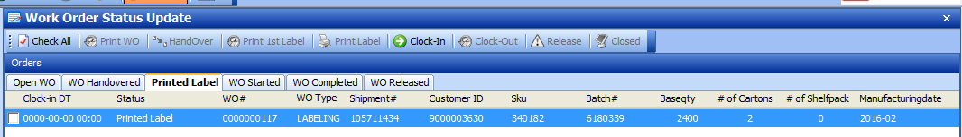

Continue to “Clock-In’, “Clock-Out” , Release and Closed WO to complete WO Process.

1. WO COMPLETED.
2. WO Detail Report 